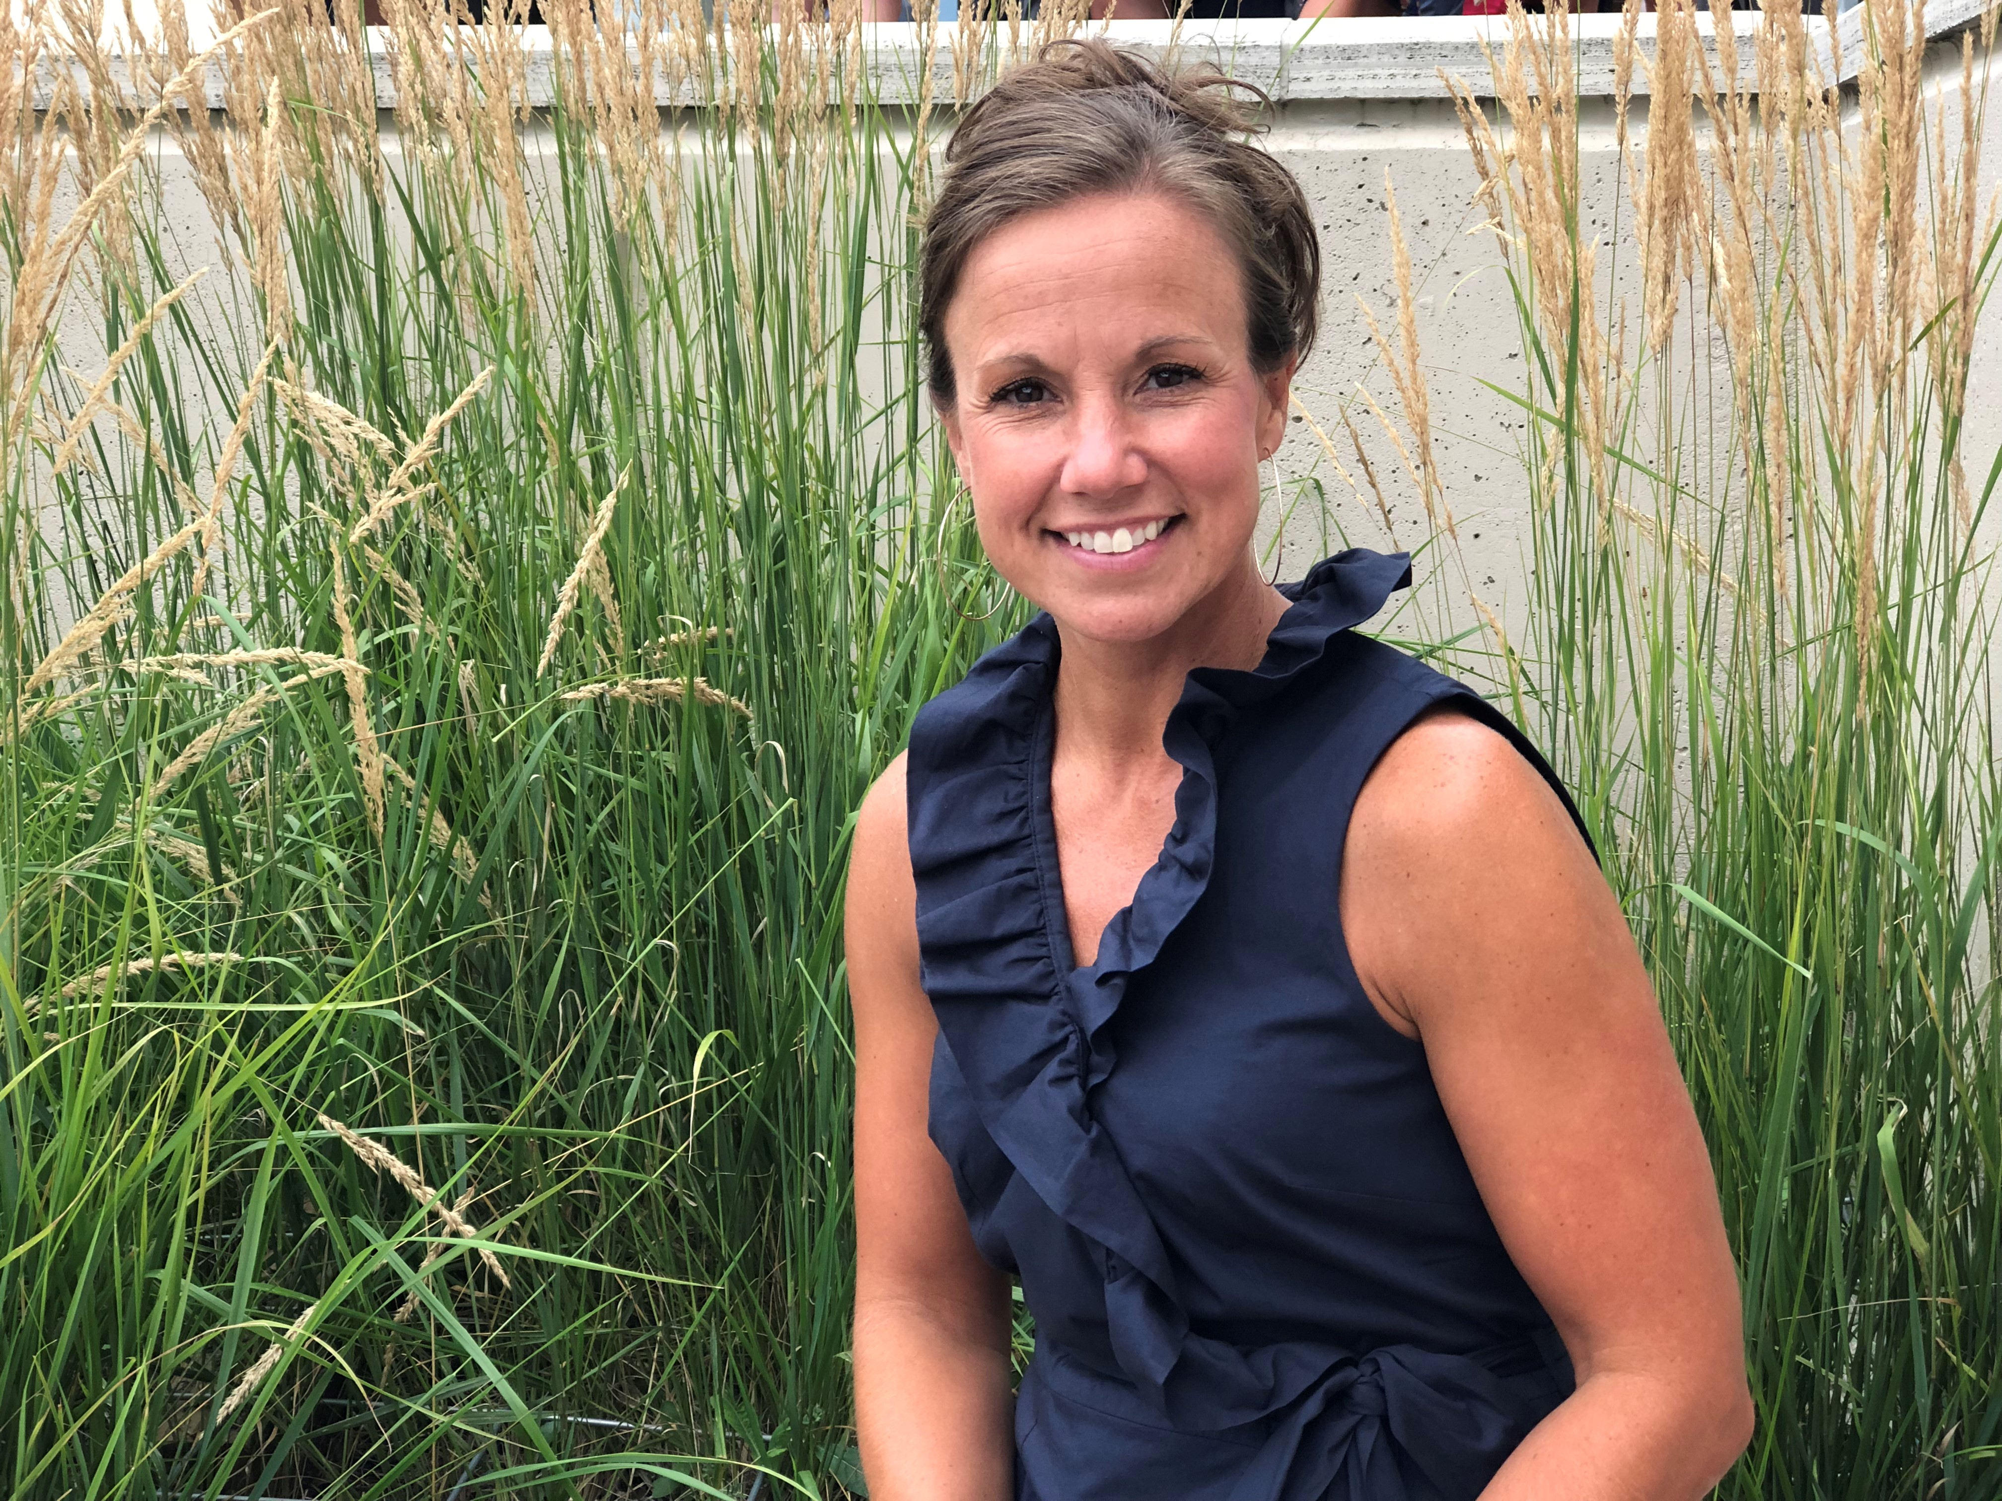

Heather L. Woody, MCC & President of Heather Woody Unlimited, Inc.

Heather L. Woody is a Success Coach that teams with individuals personally and professionally to help them experience their greatness. She has a passion for working with people as they pursue their own road to success, goal achievement and fulfilled lives. Heather is sought for her contagious energy, her ability to quickly zero in on the powerful components of a situation, flesh them out and help her clients uncover an approach that leads them to success. Heather has a strength for connecting people in their working and personal relationships in order to create flow, understanding and best outcomes. She wants for her clients to experience the changes and enhancements in their lives that open doors wide to real success.

Heather’s work as a success coach, facilitator and speaker has encompassed many areas including: leadership, team work, communication, change management, coaching, generational bridging, emotional intelligence, self-time management and project-time management. She conducts her coaching with individuals and in small team dynamics. Heather is also an experienced speaker.

As a coach and consultant, Heather has worked with clients in the following fields and industries: Coaching, Finance and Banking, Insurance, Healthcare, Utilities, Law, Real Estate, Sporting Goods, Chiropractic, Consumer Products & Services, Manufacturing, Food Service Equipment, Entrepreneurs, Computer Training, Printing & Publishing, Volunteer and Fundraising Organizations and City Governance.

Heather is a Master Certified Coach through the Certified Coach Federation. Heather is a graduate of Coach Inc., one of the largest international training organizations for professional coaches. She also holds a BA from the University of Northern Iowa in Public Relations and Communications.

She is also an accomplished collegiate athlete in track and field at Simpson College and the University of Northern Iowa. Prior to coaching she worked in marketing, public relations and sales. She resides in Iowa with her husband Joey, her son Drake and daughter Isabelle.

